Chapter-9

# CHAPTER 9: STATIC CLUSTER

## Theory

A cluster, generally, referred as a logical grouping of servers or nodes to improve performance and availability. IBM WebSphere Application Server Network Deployment has a built-in clustering function that refers to grouping of application servers that host same enterprise application(s).

In a Network Deployment cell, there can be multiple clusters depending on your needs. You can use an existing application server as a template to create cluster members or you can create and more application servers to the cluster.

Clusters can be configured in different ways to serve your business needs:

**Vertical clustering:** In this type of cluster, all members of an application server cluster reside on the same physical machine or node. You can prefer vertical clustering to use machine’s power more efficiently. Although, you can use all the processing power of the machine in a single application server, having a vertical cluster can help when a JVM reaches its limits or fails so that the other member(s) can provide failover.

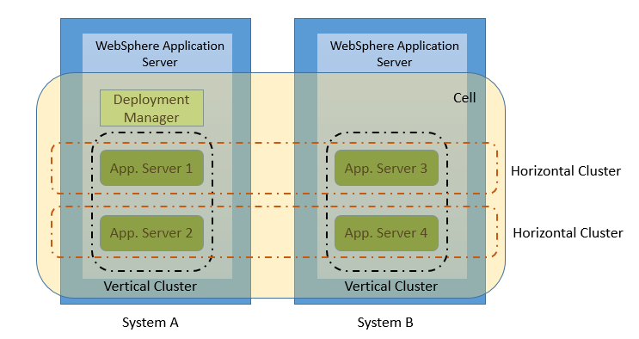

**Horizontal clustering:** In this type of clustering, cluster members are created on multiple physical machines or nodes. Horizontal clustering allows you to run an enterprise application on several machines to have usage of resources on distributed systems.

Horizontal clustering also provides a prevention against application server process failures, and hardware failures. With this failover capability, workload can be routed to other cluster members to have better availability of the application. This feature is also helpful for maintenance operations.

WebSphere Application Server can combine both vertical and horizontal clustering to use the benefits of both clustering types.

Clustering application servers provides workload management (WLM) and failover ability. In a typical cluster, following components can be workload managed:

* Http requests and web servers
* Https requests and plug-in
* EJB requests

## AIM

In this lab exercise, you will create a horizontal WebSphere Application Server cluster and then manage the weights of the cluster members. In order to achieve this goal, you need to follow following steps:

* Federate a node to a cell
* Create a static cluster
* Change weight of a cluster member

# Lab Exercise 9: STATIC CLUSTER

|  |
| --- |
| Federate Node  Create Cluster  Change Weight |

## Federate a node to a cell

## Create a static cluster

## Change weight of a cluster member

Federate Node

Create Cluster

Change Weight



**Task 1: Federate a node to a cell**

**Step 1:** Navigate to “System administration>Deployment manager>Ports” to find out the SOAP port.

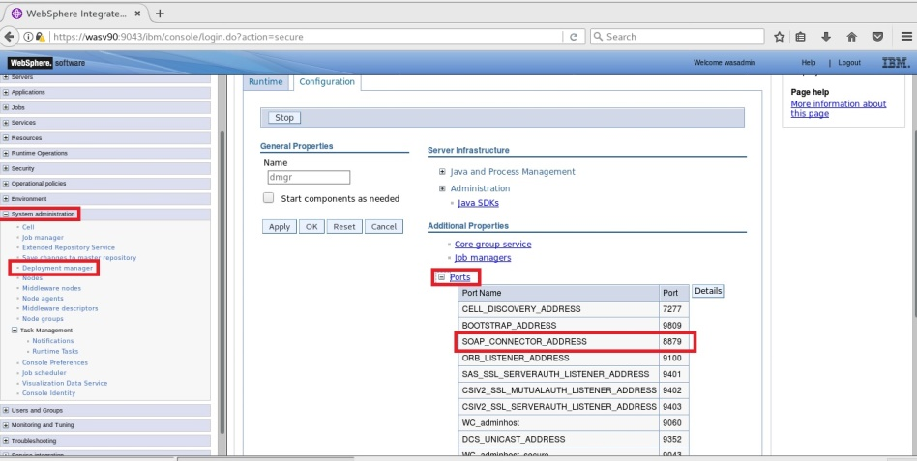

Federate Node

Create Cluster

Change Weight



**Step 2:** Use “addNode” command to federate a node.

**Note:** Run “cat /etc/hosts” in terminal to get hostname as shown below:

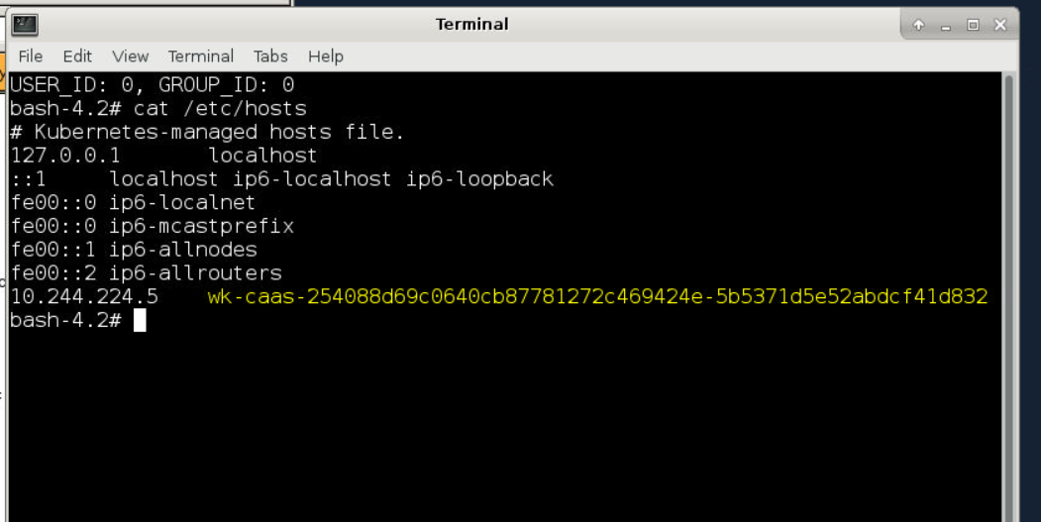

*addNode.sh <update-hostname> 8879*

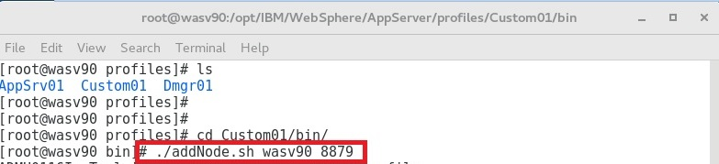

Federate Node

Create Cluster

Change Weight



**Step 3:** Enter credentials for the DMGR administrative user to perform the operation.

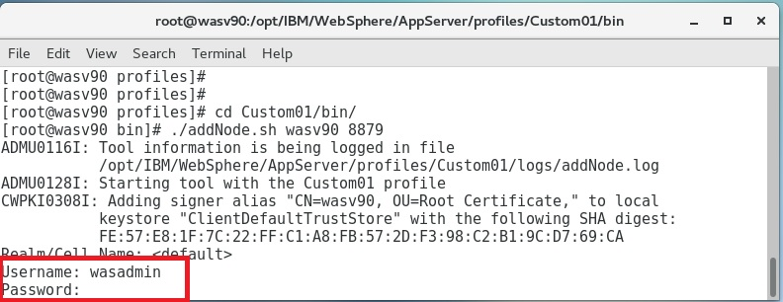

**Step 4:** You should see a success message as below.

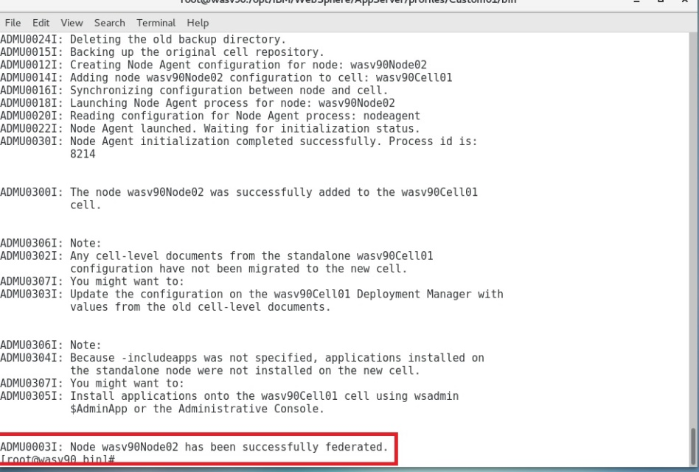

Federate Node

Create Cluster

Change Weight



**Step 5:** You have to synchronize the nodes manually. To do that, stop the node agent and issue the following command

**Note:** Run “cat /etc/hosts” in terminal to get hostname.

*syncNode.sh <update-hostname> 8879*

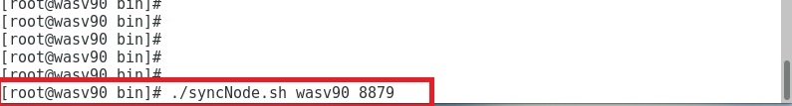

**Step 6:** Enter the administrative user credentials and click “OK”.

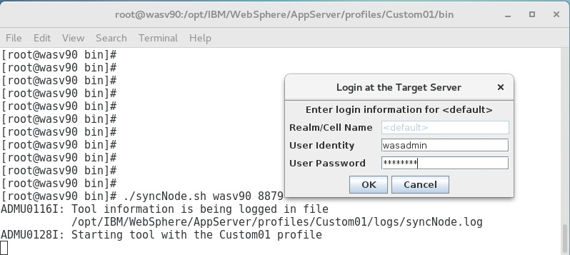

Federate Node

Create Cluster

Change Weight



**Step 7:** You should see the success message as below.

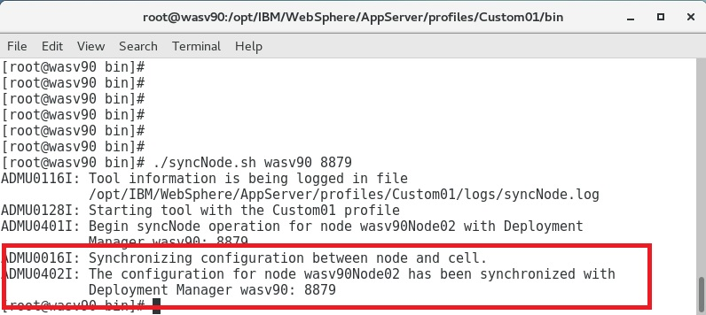

**Step 8:** Now, you can check and synchronize the nodes using the admin console. (System administration>Nodes)

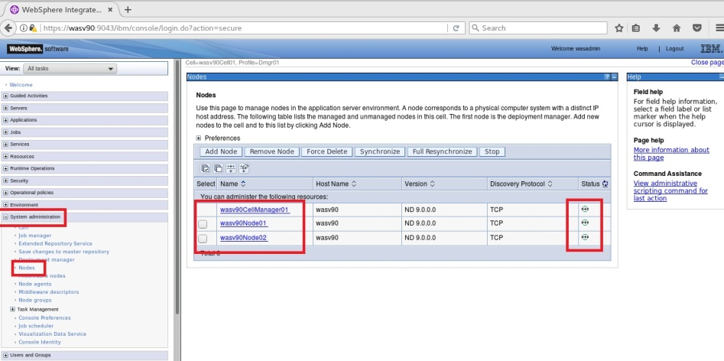

Federate Node

Create Cluster

Change Weight



**Step 8 (Optional):** Rest of the steps are optional to show that you can add new application servers using admin console. Navigate to “Servers>Server Types>WebSphere application servers” and click “New”.

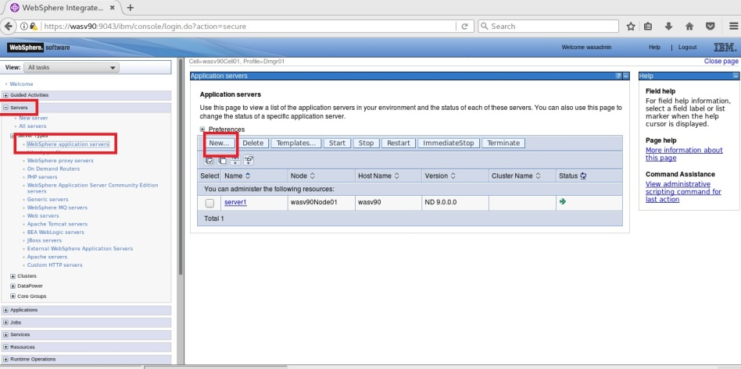

**Step 9 (Optional):** Select the node and enter a name for the new application server.

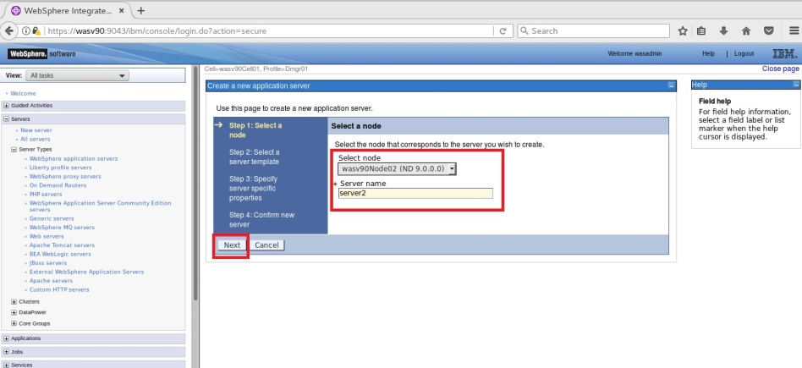

Federate Node

Create Cluster

Change Weight



**Step 10 (Optional):** Select a server template and click “Next”.

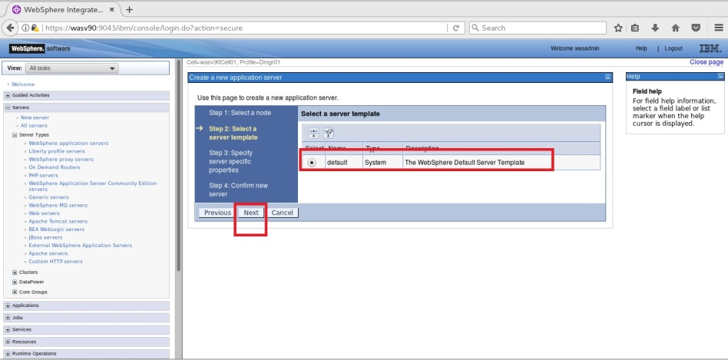

**Step 11 (Optional):** Mark “Generate Unique Ports” and click “Next”.

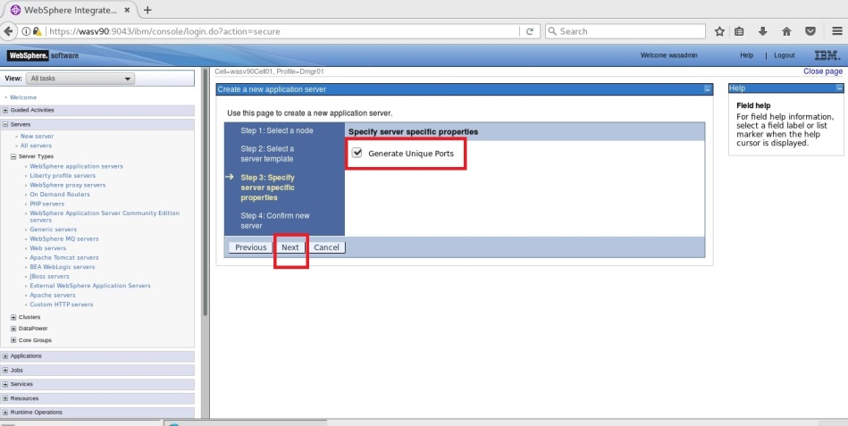

Federate Node

Create Cluster

Change Weight



**Step 12 (Optional):** Review the summary of actions and then click “Finish”.

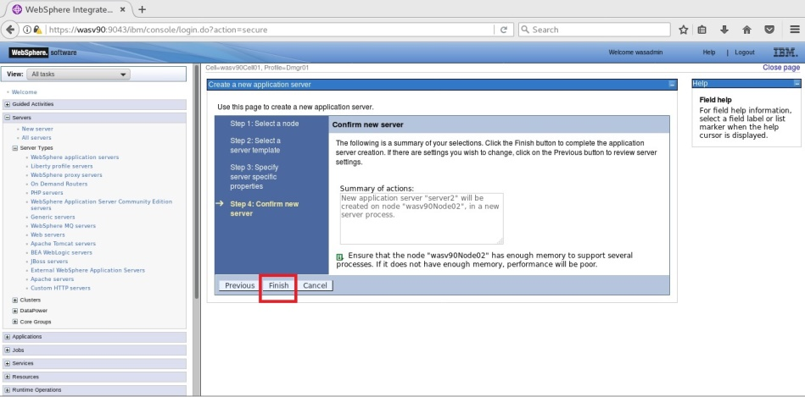

Federate Node

Create Cluster

Change Weight



**Step 13 (Optional):** Click “Save” to write changes to the master file.

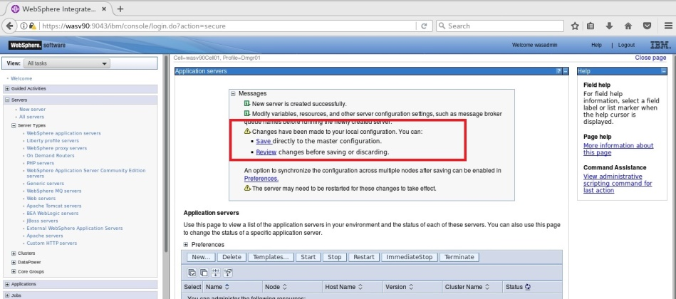

**Step 14 (Optional):** Select the newly created server and click “Start”.

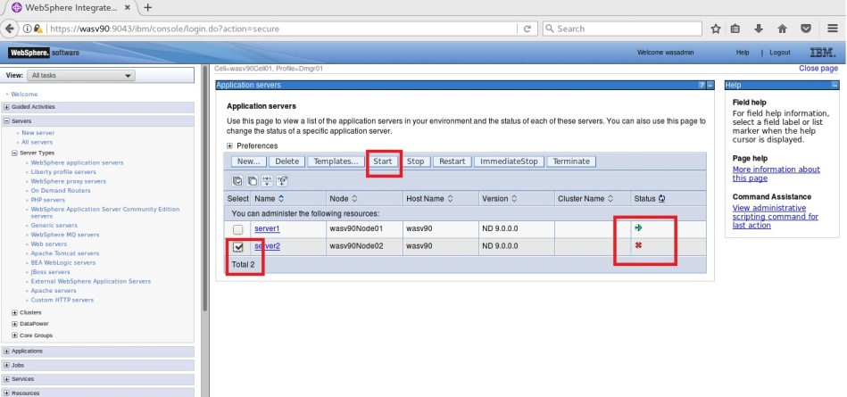

Federate Node

Create Cluster

Change Weight



**Step 15 (Optional):** You should see the application server we just created is started successfully.

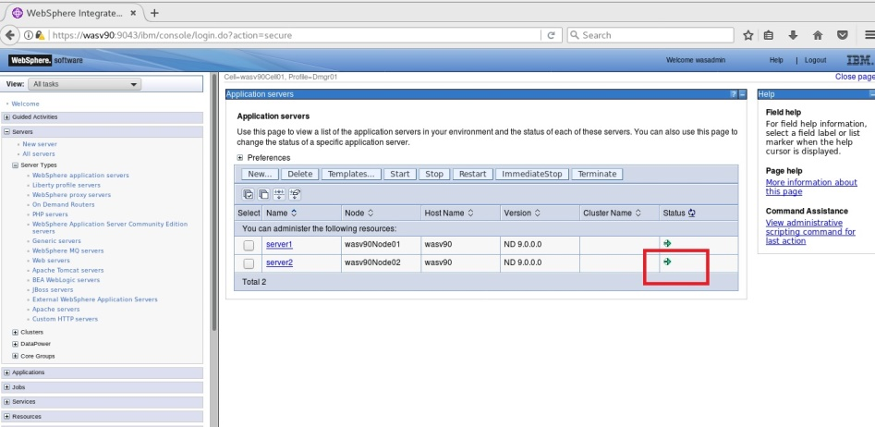

**Task 1 is complete!**

Federate Node

Create Cluster

Change Weight



**Task 2: Create a static cluster**

**Step 1:** Navigate to “Servers>Clusters>WebSphere application server clusters” and click “New”.

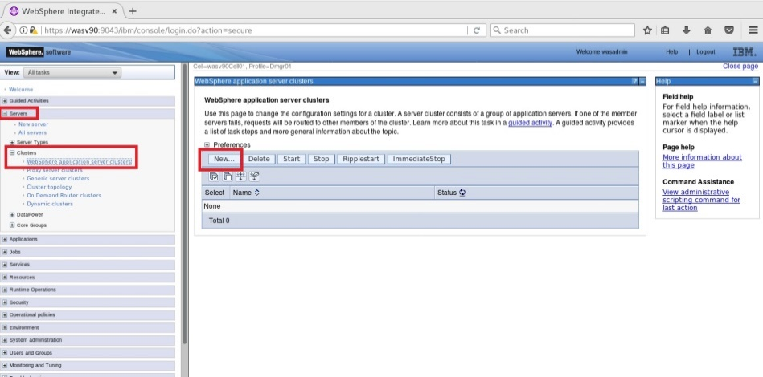

Federate Node

Create Cluster

Change Weight



**Step 2:** Enter a cluster name and click “Next”.

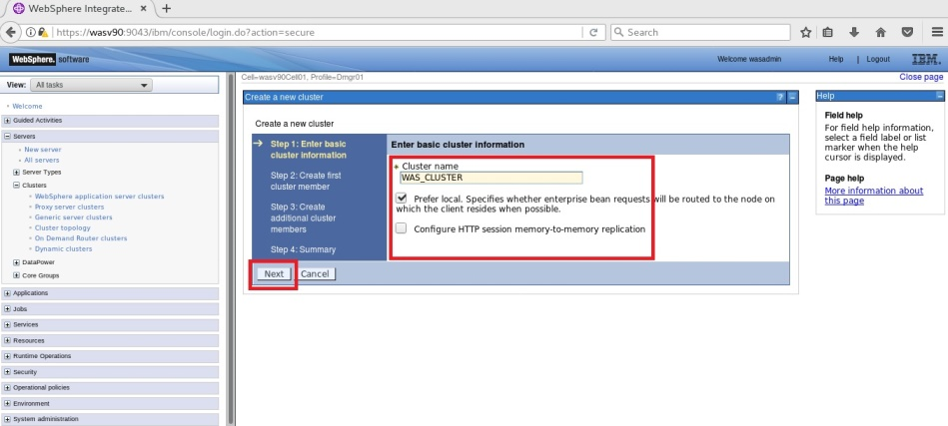

Federate Node

Create Cluster

Change Weight



**Step 3:** Enter a name for the new cluster member to be created and select the target node. You can define also the weight of the cluster member. Then select basis for the first cluster member and click “Next”.

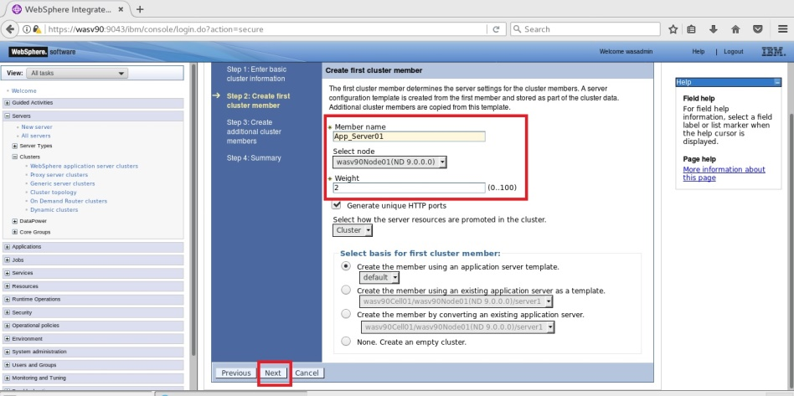

Federate Node

Create Cluster

Change Weight



**Step 4:** In this step, we will create additional cluster members. For this example, we will add a member to be created on the second node and click “Add Member”.

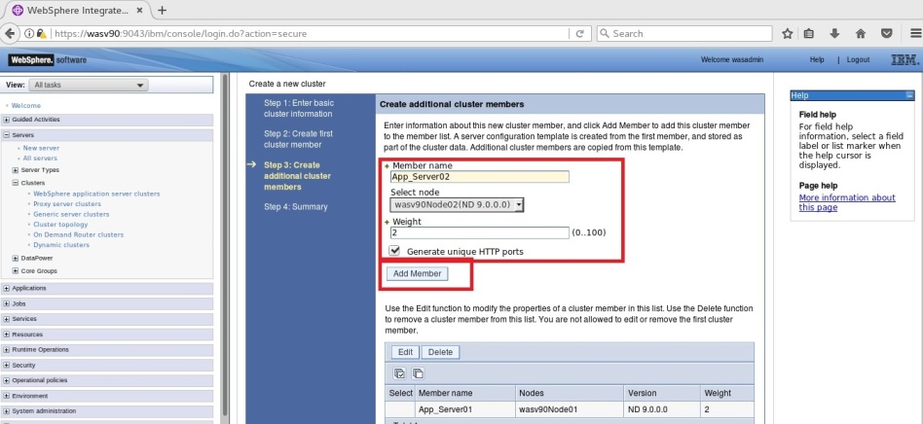

Federate Node

Create Cluster

Change Weight



**Step 5:** Click “Next” when you finish adding the cluster members.

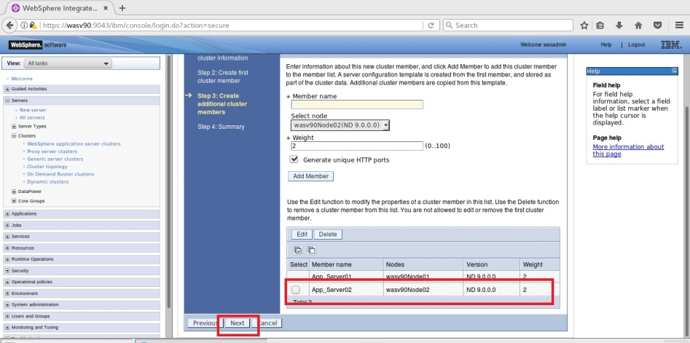

Federate Node

Create Cluster

Change Weight



**Step 6:** Review the configuration and click “Finish”.

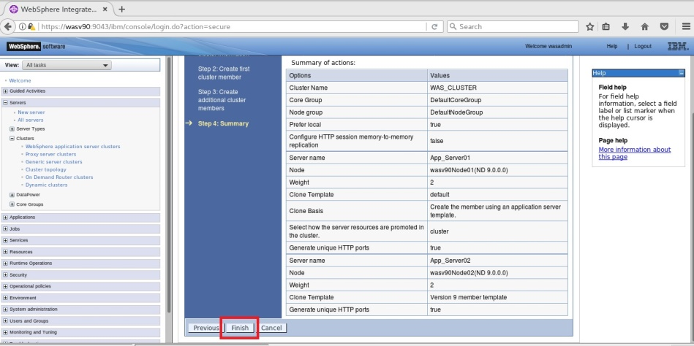

Federate Node

Create Cluster

Change Weight



**Step 7:** Click “Save” to write changes directly to the master file.

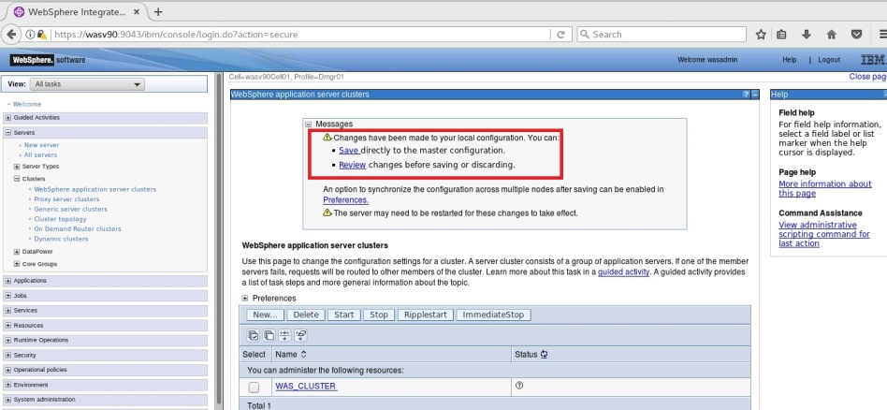

**Step 8:** Select the newly created cluster and click “Start”.

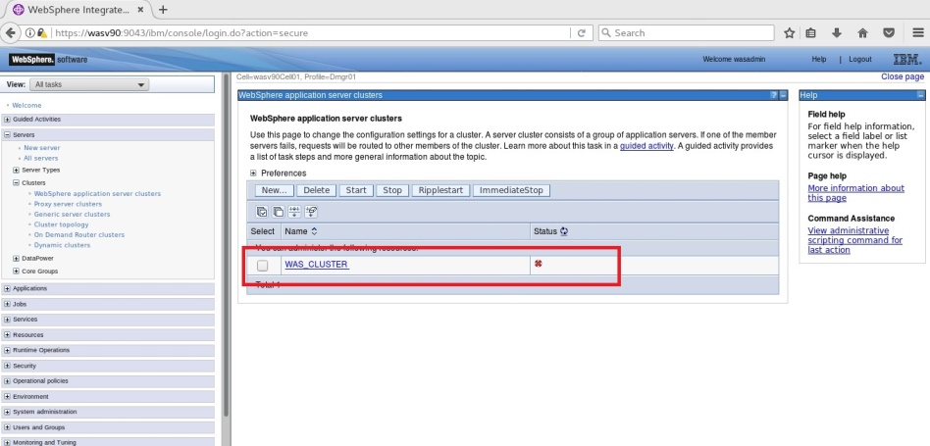

Federate Node

Create Cluster

Change Weight



**Step 9:** You should see the cluster as started as below.

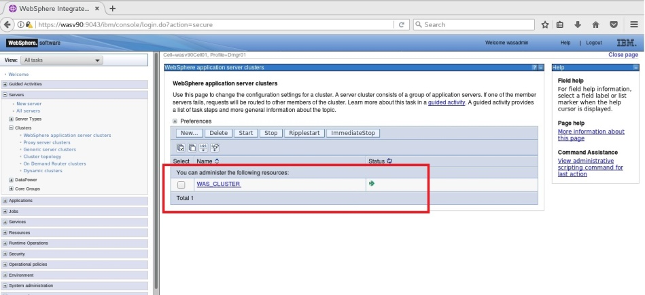

**Step 10:** You can check the topology of clusters by navigating “Servers>Clusters>Cluster Topology”.

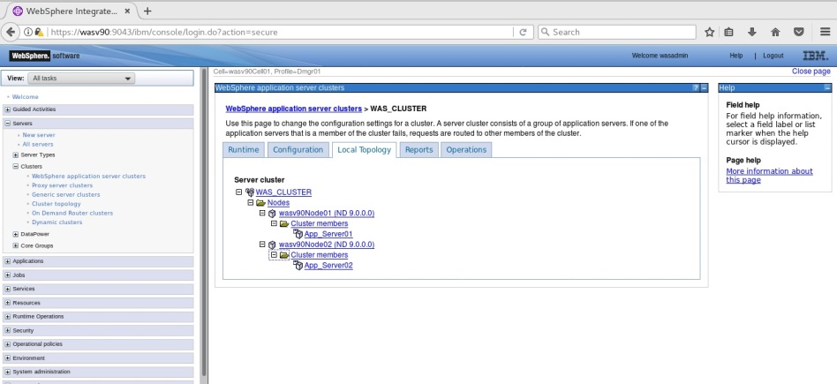

**Task 2 is complete!**

Federate Node

Create Cluster

Change Weight



**Task 3: Change weight of a cluster member**

**Step 1:** Navigate to “Servers>Clusters>WebSphere application server clusters” and click on the name of the cluster.

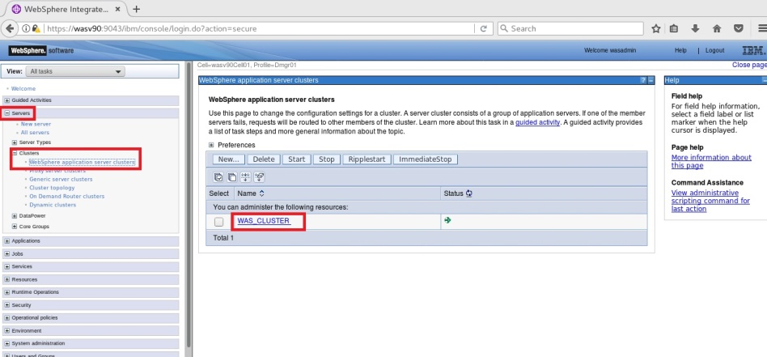

Federate Node

Create Cluster

Change Weight



**Step 2:** Click on “Cluster members”.

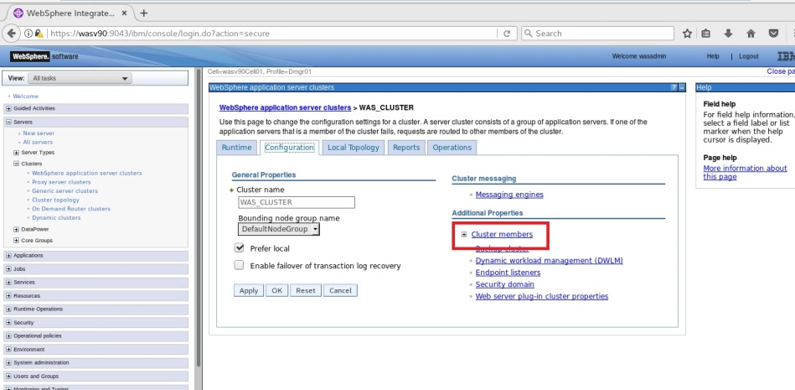

Federate Node

Create Cluster

Change Weight



**Step 3:** Click on “Details” to continue.

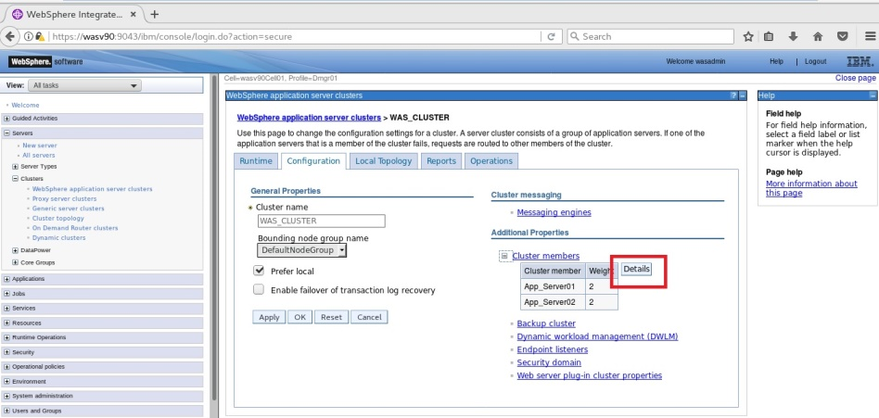

Federate Node

Create Cluster

Change Weight



**Step 4:** Change the “Configure weight” value of “App-Server02” to “4” and click

“Update”.

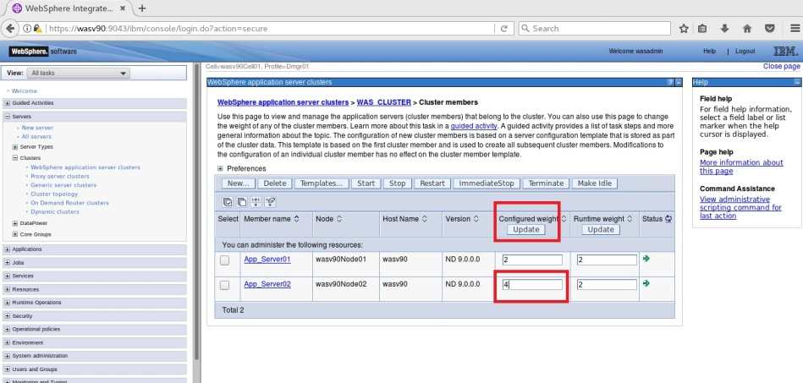

**Step 5:** Click “Save” to save the changes to master file.

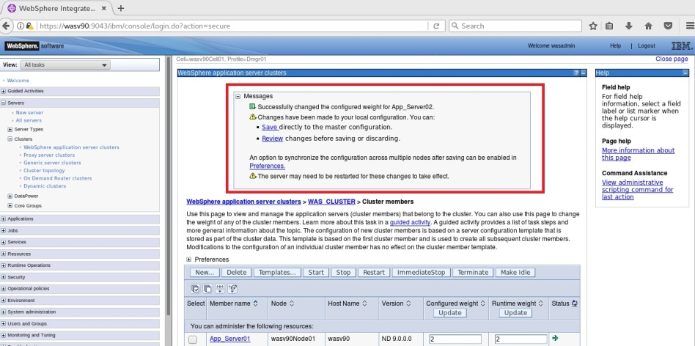

Federate Node

Create Cluster

Change Weight



**Step 6:** You should see newly configured weight of cluster members.

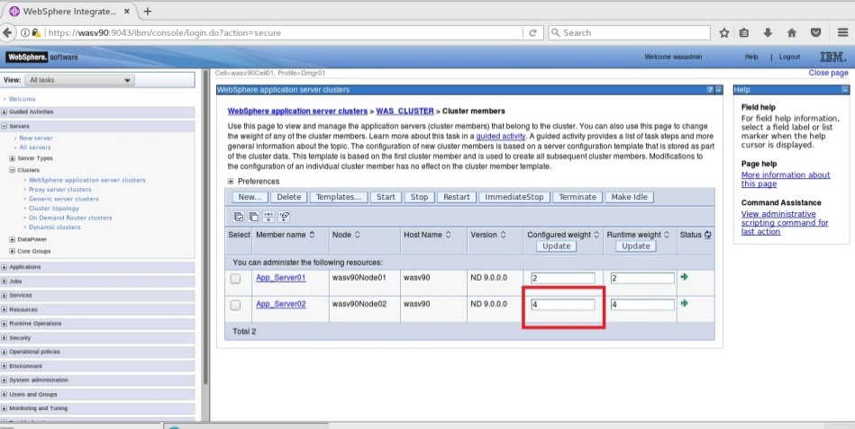

**Task 3 is complete!**

# SUMMARY

IBM WebSphere Application Server Network Deployment has a built-in clustering function that refers to grouping of application servers that host same enterprise application(s). There are two types of clustering that are vertical clustering and horizontal clustering. In IBM WebSphere Application Server, you can use vertical, horizontal or hybrid of vertical and horizontal clustering. Horizontal clustering provides failover feature that gives higher availability of your applications. Different components can be workload managed to have scalability and failover for applications that run on an application server cluster.

# REFERENCES

* http://pic.dhe.ibm.com/infocenter/ramhelp/v7r2m0/index.jsp?topic=/com.ibm.ram.installguide.doc/topics/c_clusters.html
* http://pic.dhe.ibm.com/infocenter/clmhelp/v4r0m2/index.jsp?topic=%2Fcom.ibm.jazz.install.doc%2Ftopics%2Ft_deploy_cluster_was_nd.html
* https://publib.boulder.ibm.com/infocenter/ieduasst/v1r1m0/index.jsp?topic=/com.ibm.iea.was_v6/was/6.0/WLM_HA.html

# INDEX

cluster 68, 277

Horizontal cluster 277

Vertical cluster 277

workload management 278

CHAPTER 10: APPLICATION DEPLOYMENT